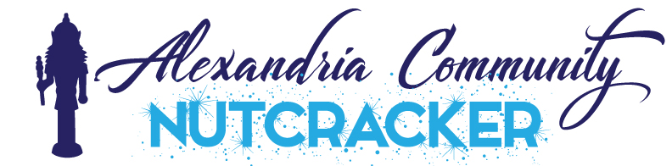

Dancer’s Name ______________________________ Age ________
School Attending 2019 _______________
Parents Name ______________________ Email Address____________________
Phone Number___________________
Studio where you study dance or gymnastics ____________________________
Phone Number of Studio ______________________
If this studio will change for Fall 2019 – New Studio ________________________
Phone Number of Studio ______________
Dance Styles you study ____________________________________________
I, ________________________ understand that my dancer must do the following to be participate in the ACN11.
- Study dance or gymnastics for the dance year 2019-20 at a studio, gym, or dance team.
- Be available for ALL practices and ALL performances.
Practices are Tuesday evenings although leads may practice other days and times.
Dress Rehearsal is Sunday November24th
Must be available week of December 2-7 for all Dress Rehearsals and Performances.
I also understand that by attending this audition I am committing to the show as a whole not an individual role. I understand that ALL roles are important to ACN11 and I am committing to whatever role the directors feel is suitable for my dancer. Roles are also not negotiable and the directors will not consider changes based on parent or dancer requests.

Parent’s Signature _____________________________________

